**Raspberry Pi Setup**

**5” HDMI NightScout Display**

2017-09-30 Notes: Instructions to switch to chromium-browser highlighted in yellow.

# Items Needed:

* Raspberry Pi with Debian Jessie loaded and configured. See Part_1_OS_Install.docx to build one if you don’t already have one.
* Elecrow 5” HDMI Touch Screen Monitor ($38.99) <https://amzn.com/B013JECYF2>
* Optional: Plastic Frame and Mount ($9.99) <https://amzn.com/B00ZZOY6KQ>

# Assumptions:

* You are running a Raspberry Pi 3 configured as described above. The most notable requirement is:
  + Your Pi 3 automatically logs in and boots to the X-Windows Desktop

# Download and Configure Chromium-Browser to Auto Launch your NightScout Website

* Ensure your Pi is up-to-date. Open a terminal window and run the following commands:
  + sudo apt-get update
  + sudo apt-get upgrade
* Install Chromium-Browser
  + sudo apt-get install chromium-browser

# Install the 5” HDMI Screen

* Prepare for the installation by downloading the unclutter and xinput-calibrator applications
  + sudo apt-get install unclutter
  + sudo apt-get install xinput-calibrator
* Modify the /boot/config.txt to support the 5” display:
  + sudo nano /boot/config.txt
  + Find the line #disable_overscan=1 and remove the octothorp (#) to end up with disable_overscan=1
  + Scroll down to the line below #hdmi_drive=2 and enter the following:
    - hdmi_group=2
    - hdmi_mode=1
    - hdmi_mode=87
    - hdmi_cvt 800 400 60 6 0 0 0
    - dtparam=spi=on
    - dtparam=i2c_arm=on
    - dtoverlay=ads7846,cs=1,penirq=25,penirq_pull=2,speed=50000,keep_vref_on=0,swapxy=0,pmax=255,xohms=150,xmin=200,xmax=3900,ymin=200,ymax=3900 (Note this is all on 1 line!)
    - dtoverlay=w1-gpio-pullup,gpiopin=4,extpullup=1

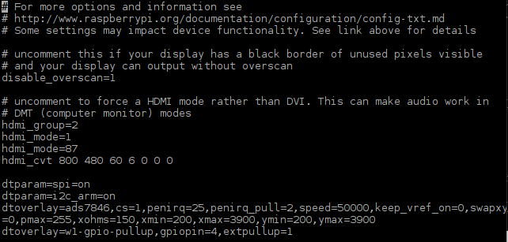

* + NOTE: On Amazon and other places on the web, there is talk about loading the “driver” for this device. It appears the so-called driver just copies configuration files to a number of places on your Pi. When it does this, some of them are incorrectly written and the next time you try to boot your Pi it will crash and you will be unable to recover. So the moral of the story is to follow these directions and **DO NOT INSTALL THE ELECROW HDMI DRIVER**!
* Now shutdown your Pi and move to the next step to install the 5” display
  + sudo shutdown -h now

# Installing the 5” Display:

* The display kit contains a screen, four standoffs, four nuts, a stylus pen, and an HDMI-HDMI connector that eliminates the need for a cable.

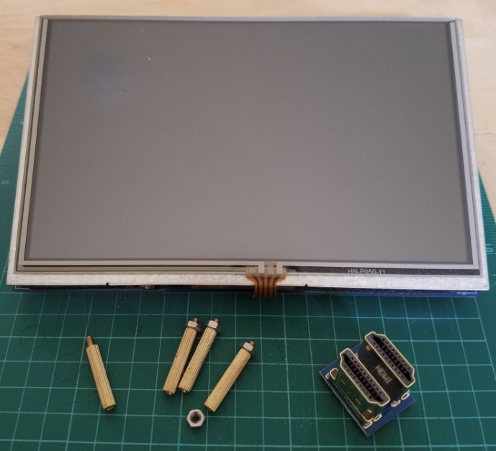

* Install the standoffs on the back of the screen. Leave the nut off the standoff closest to the HDMI connector as this nut will be installed after installing the Raspberry Pi.

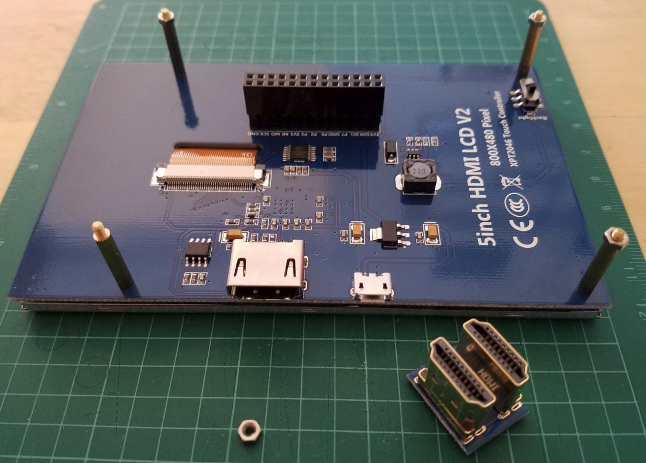

* Install the Pi onto the board. You need to do this carefully as some of the GPIO Pins are used, but not all of them. The easiest way to know things are aligned properly is to ensure the HDMI ports (the one on the Pi and the one on the monitor) end up right next to each other. Additionally, the standoff without the nut should pass through the hole on the Pi closest to the HDMI port.

Ensure the HDMI Ports are aligned with each other, the standoff without the nut will pass through the hole in the Pi, and that the GPIO pins are properly aligned with the header on the display.

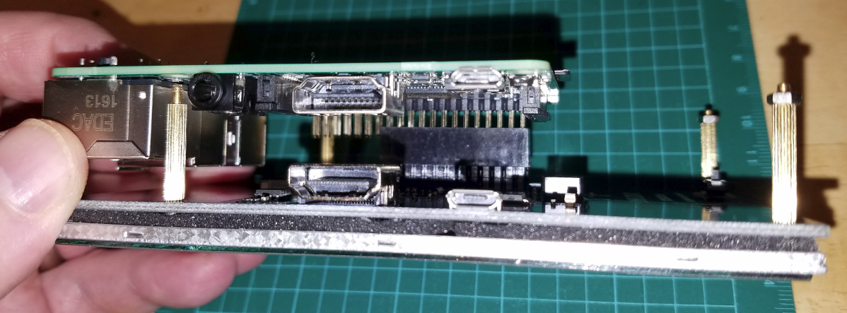

Here is a view from the opposite side. The header should “use” the GPIO pins that are the furthest from the USB ports on the Pi. Press the board down fully to seat the GPIO pins in the header. There are 14 unused pins closest to the USB connectors

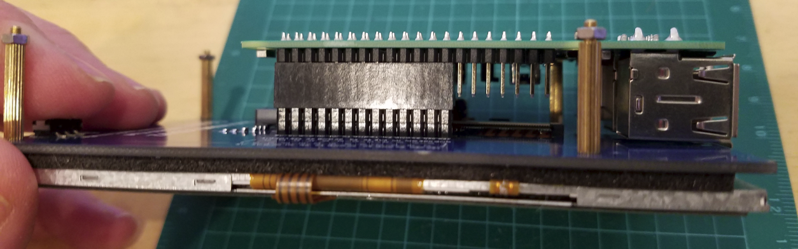

When properly installed, the standoff passes right through the hole in the Pi, and the HDMI ports end up next to each other.

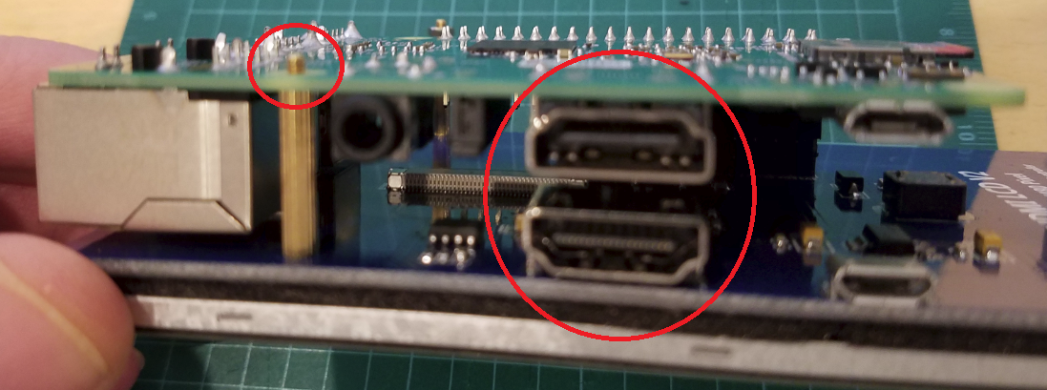

Install the HDMI connector between the Pi and the Display. Do this prior to installing the nut.

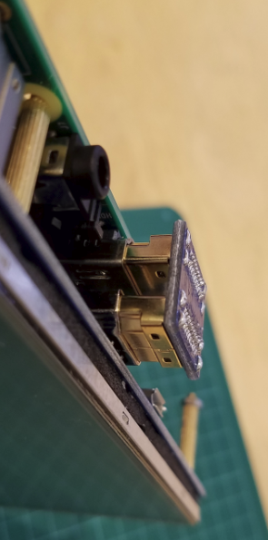

Finally, install the nut to secure the board. It doesn’t need to be torqued very tightly, maybe a ¼ turn past finger tight.

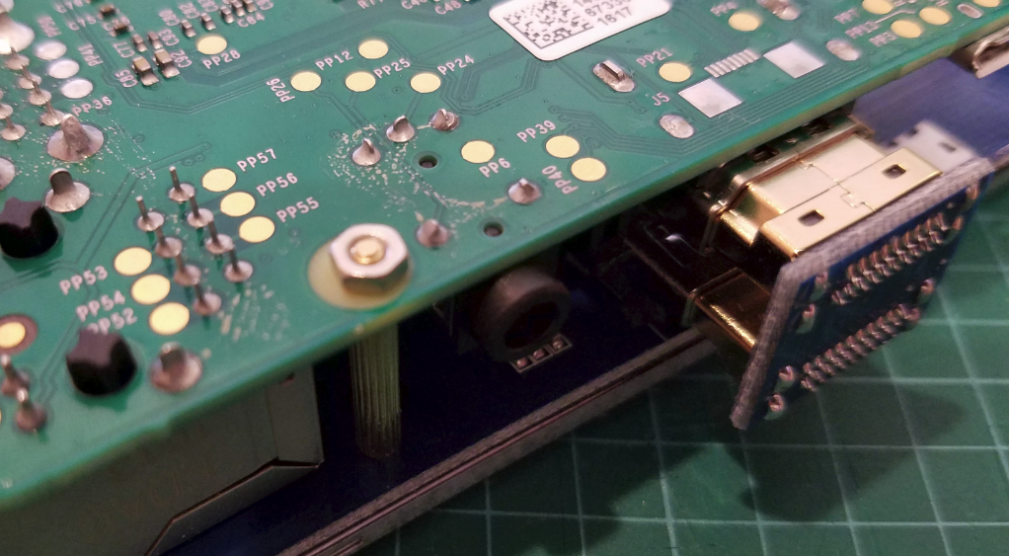

# Touch Screen Calibration

* Reconnect your mouse and keyboard, and then reconnect your Pi to power and if all is well it should boot and the picture on the monitor should be clear and cover the full width of the screen.

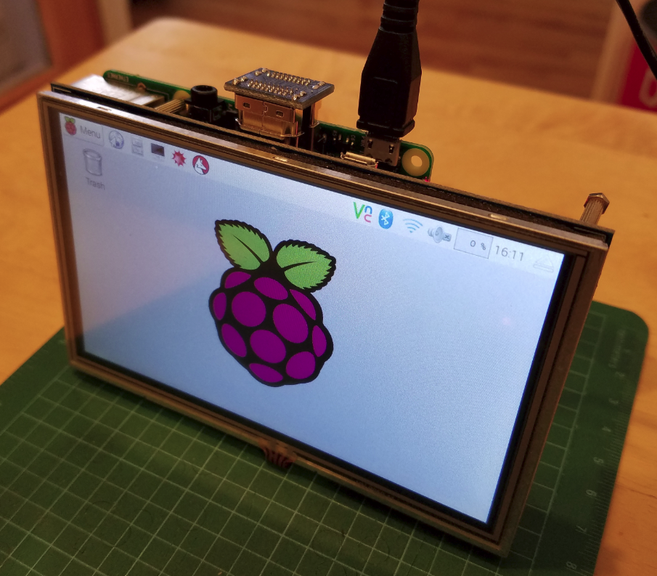

* You can now calibrate the touch screen. Select Menu, Preferences, Calibrate Touchscreen.

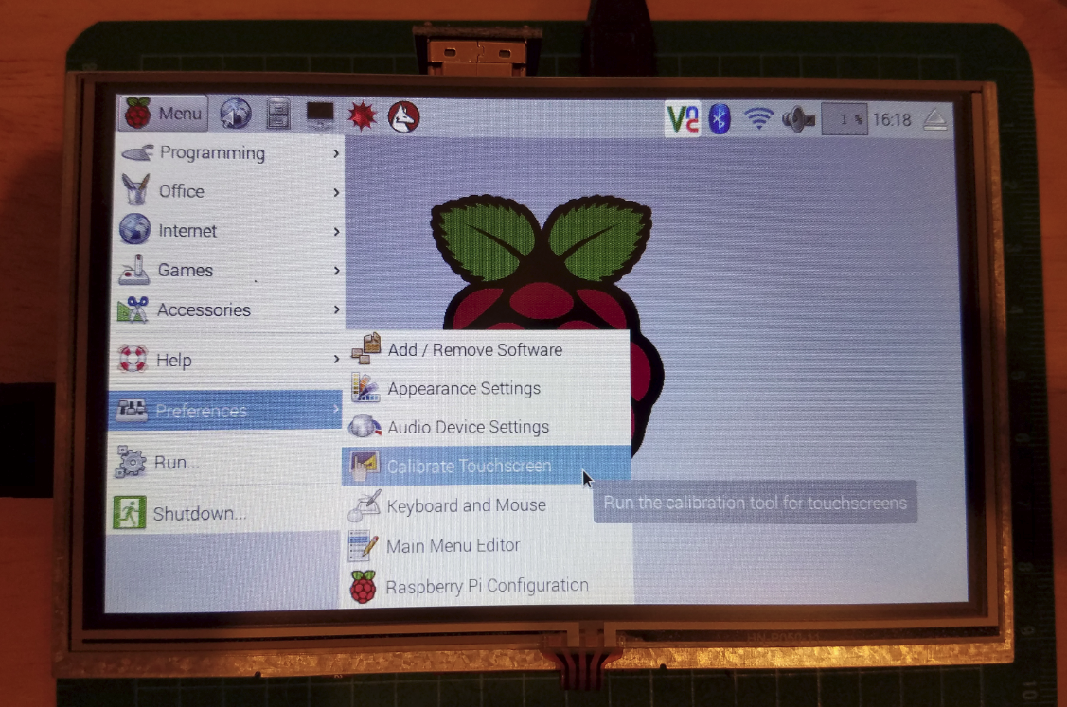

* Once opened, use the supplied stylus to touch each target on the calibration screen

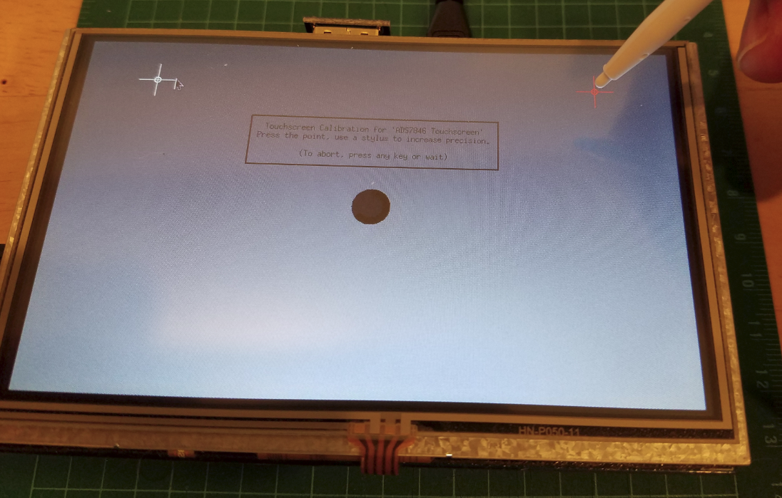

* After calibrating a screen will appear that shows the calibration code you need to add to the 99-calibration.conf file. For the Raspberry Pi the file should be in /usr/share/X11/xorg.conf.d

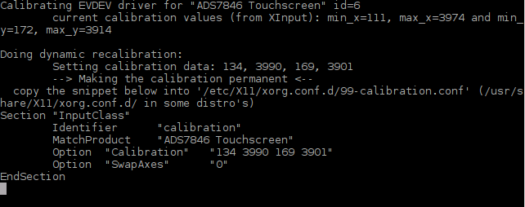

* To create the new file:
  + sudo nano /usr/share/X11/xorg.conf.d/99-calibration.conf
  + Add the data from the calibration screen:

Section “Input Class”

Identifier “calibration”

MatchProduct “ADS7846 Touchscreen”

Option “Calibration” “*Enter Your Calibration Here*”

Option “Swap Axes” “0”

EndSection

* + Press Control-x to save and exit Nano
* You should now be able to use your touch stylus instead of the mouse to navigate the window. You can disconnect the mouse at this time.

# Final NightScout Configuration:

* Disable the screen saver, hide the mouse cursor, and autostart Midori in fullscreen mode:
  + Edit the autostart file in the home directory:
    - nano ~/.config/lxsession/LXDE-pi/autostart
    - Enter the info shown below and press Control-x to save and exit.

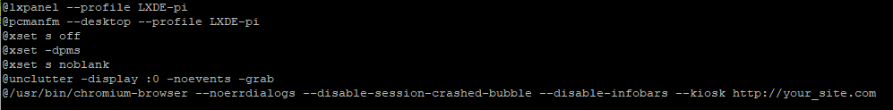

* Reboot your Pi and it should come back with your NightScout website displayed in full screen mode, with no scrollbars, no mouse cursor, and the screen saver shouldn’t activate. (Yeah! Michele’s BG is getting better)

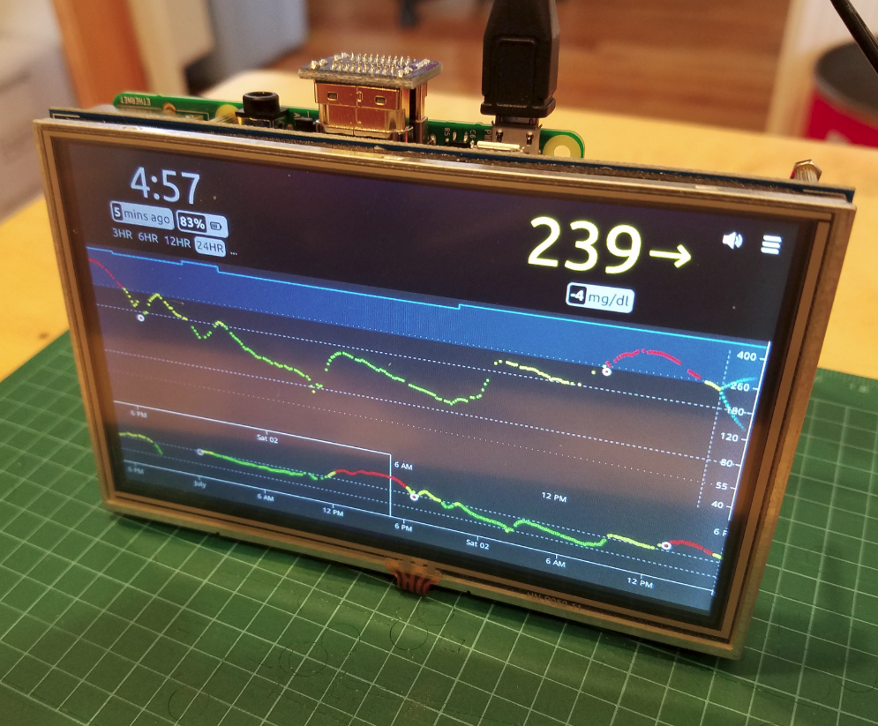

* You can remove the keyboard now. and the project is complete. If you ever need to get out of fullscreen mode, reconnect your keyboard and press F11 to get back to normal. Note the mouse cursor won’t be visible, but you can use the touchscreen stylus to hunt and peck at what you need.

Please let me know if you find any errors or come up with any improvements to this procedure. My email address is in the footer on each page.